AD23B31 - Image Processing and Computer Vision

A MINI PROJECT REPORT
On
Facial Emotion Recognition using Deep Feature Extraction (VGG16) and Machine Learning Classification

Submitted by
SHERYL KATRINA. M


March, 2026

TABLE OF CONTENTS

Chapter No. | Title |  | Page No.
Cover Page |  | Title Page | i
Table of Contents |  | Contents | ii
List of Tables & Figures |  | Index | iii
1 |  | Introduction | 3
2 |  | Literature Review | 5
3 |  | Dataset Description | 6
4 |  | Preprocessing Methodology | 9
5 |  | Proposed Algorithm & Implementation | 11
6 |  | Results and Analysis | 15
7 |  | Discussion | 21
8 |  | Conclusion and Future Work | 23
References |  | IEEE References | 24
Appendix A |  | Source Code | 25
Appendix B |  | Output Screenshots | 36

1 – INTRODUCTION

1.1 Background
Facial expressions are one of the most important forms of non-verbal communication and play a significant role in conveying human emotions. Automatic Facial Emotion Recognition (FER) is a branch of computer vision and pattern recognition that focuses on identifying human emotional states from facial images. FER systems are increasingly used in applications such as human-computer interaction, online education monitoring, healthcare diagnosis, driver fatigue detection, surveillance systems, and sentiment-aware virtual assistants.
The development of FER systems presents several challenges due to variations in facial pose, lighting conditions, occlusion, facial structure, and subtle differences between similar expressions. Traditional deep learning methods require large computational resources and extensive training data. Therefore, feature engineering-based approaches remain relevant due to their interpretability, lower computational complexity, and suitability for moderate-scale datasets.
In this project, to overcome this, this project uses a pretrained VGG16 model through OpenCV’s DNN module (cv2.dnn) to extract deep features, followed by machine learning classification using SVM.

1.2 Problem Statement
Emotion recognition from facial expressions is a challenging image classification problem due to:
- intra-class facial variations,
- low image resolution,
- background noise,
- inconsistent illumination,
- class imbalance in datasets,
- overlapping emotional characteristics between categories.
The objective is to develop an efficient computer vision system capable of automatically recognizing multiple human emotions from facial images with reasonable accuracy using feature engineering and machine learning techniques.

1.3 Objectives
The primary objectives of this project are:
- To develop an automated facial emotion recognition pipeline using computer vision techniques.
- To preprocess facial images for improved visual quality and consistency.
- To extract meaningful discriminative features using:
  - Extract deep features using VGG16 (cv2.dnn)
  - Train classifiers (mainly SVM)
- To combine texture and structural features into a hybrid feature representation.
- To train and compare multiple machine learning classifiers including:
  - Support Vector Machine (SVM)
  - K-Nearest Neighbors (KNN)
  - Random Forest
- To evaluate model performance using:
  - Accuracy
  - F1 Score
  - Confusion Matrix
  - Precision–Recall Curve
  - ROC Curve
- To identify the best-performing model for practical deployment.

1.4 Scope of the Project
The scope of this project includes:
- Facial emotion recognition on grayscale static images.
- Classification of seven emotions:
  - Angry
  - Disgust
  - Fear
  - Happy
  - Sad
  - Surprise
  - Neutral
- Feature engineering-based classification.
- Comparative performance analysis of classifiers.
- Visualization of preprocessing, extracted features, and evaluation metrics.
The project does not include:
- video stream emotion recognition,
- facial landmark tracking,
- multimodal sentiment analysis (speech + image),
- deep neural network training.

1.5 Contribution of the Work
The major contributions of this project include:
- Development of a complete FER pipeline.
- Use of pretrained VGG16 via OpenCV DNN.
- Image enhancement using CLAHE and Gaussian denoising.
- Comparative study of multiple classifiers.
- Selection of optimal classifier based on empirical evaluation.
- Visualization-driven interpretation of model performance.

2 – LITERATURE REVIEW

2.1 Introduction
Facial Emotion Recognition has been an active research area in computer vision for many years. Existing approaches can be broadly categorized into:
- geometric feature-based methods,
- appearance-based methods,
- handcrafted feature engineering methods,
- deep learning approaches.
Among these, handcrafted feature extraction techniques remain computationally efficient and interpretable for medium-scale datasets.

2.2 Deep Feature Extraction using VGG16 (cv2.dnn)
Deep learning models have significantly improved the performance of image classification tasks. In this project, the VGG16 model is used as a feature extractor through the OpenCV DNN module.
VGG16 is a pretrained Convolutional Neural Network that has been trained on large-scale image datasets. Instead of training the network from scratch, it is utilized to extract high-level deep features from facial images.
These features represent complex patterns such as:
- facial structure,
- muscle movements,
- texture variations,
- spatial relationships between facial regions.
Advantages:
- captures high-level semantic features,
- eliminates need for training deep networks from scratch,
- improves classification performance,
- suitable for transfer learning applications.
Limitations:
- computationally heavier than handcrafted features,
- requires proper preprocessing and scaling,
- less interpretable compared to traditional features.

2.3 Machine Learning Classification using SVM
After extracting deep features, classification is performed using the Support Vector Machine (SVM).
SVM is a powerful supervised learning algorithm that constructs an optimal decision boundary (hyperplane) in a high-dimensional feature space.
Advantages:
- effective for high-dimensional feature vectors,
- robust against overfitting,
- works well with limited datasets,
- strong generalization capability.
Limitations:
- requires parameter tuning (C, kernel, gamma),
- higher training time compared to simple models,
- not inherently probabilistic.

2.4 Deep Feature-Based Approach
Recent studies emphasize the use of pretrained deep learning models for feature extraction instead of handcrafted descriptors.
The proposed approach uses:
- VGG16 for deep feature extraction
- SVM for classification
This combination provides:
- richer feature representation,
- improved class separability,
- better generalization performance,
- reduced need for large-scale training.
Unlike traditional methods, deep features capture both structural and textural information automatically, making them more effective for facial emotion recognition tasks.

2.5 Research Gap Identified
Existing approaches typically focus on:
- handcrafted feature extraction methods or
- fully trained deep learning models requiring high computational resources.
There is a need for a balanced approach that:
- leverages deep learning capabilities,
- avoids expensive training processes,
- remains suitable for academic and moderate-scale applications.
This project addresses the gap by:
- using pretrained VGG16 for feature extraction,
- combining it with efficient machine learning classification (SVM),
- providing a computationally feasible and effective FER system.

3 – DATASET DESCRIPTION

3.1 Dataset Overview
The dataset used for this project is the FER2013 (Facial Expression Recognition 2013) dataset, a benchmark dataset widely used for emotion recognition research. The dataset consists of grayscale facial images categorized into seven distinct emotional classes. Each image captures a human facial expression under varying lighting conditions, poses, and facial structures, thereby making the classification task challenging and realistic.
The FER2013 dataset is suitable for this project because:
- it contains a sufficiently large number of labeled facial images,
- it supports multi-class emotion classification,
- it provides both training and testing splits,
- it is widely referenced in facial expression recognition literature,
- it enables comparative performance analysis.
The seven emotion categories considered in this project are:
- Angry
- Disgust
- Fear
- Happy
- Sad
- Surprise
- Neutral

3.2 Dataset Statistics
The complete class distribution of the FER2013 dataset obtained during data loading is summarized below based on your implementation outputs.

Table 1: FER2013 Dataset Class Distribution
Emotion Class | Training Images | Testing Images
Angry | 3995 | 958
Disgust | 436 | 111
Fear | 4097 | 1024
Happy | 7215 | 1774
Sad | 4830 | 1247
Surprise | 3171 | 831
Neutral | 4965 | 1233
Total | 28,709 | 7,178

Analysis:
From Table 1, it is evident that the dataset is imbalanced. The Happy class contains the highest number of samples, whereas Disgust contains the fewest. Such imbalance can influence classifier bias toward majority classes, making weighted evaluation metrics important.
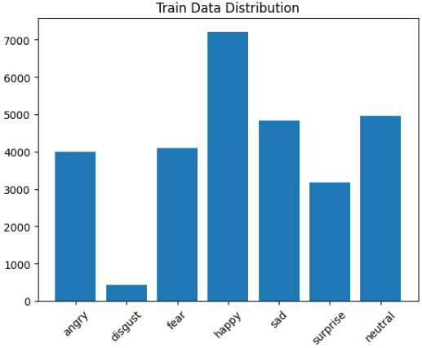
Figure 3.1: Dataset Distribution Bar Chart

3.3 Data Sampling Used for Project
To reduce computational overhead and enable rapid experimentation, a controlled subset of the FER2013 dataset was used.
The following sampling strategy was adopted:
- Training set: maximum 500 images per class
- Testing set: maximum 100 images per class
This produced a balanced experimental subset (except for classes with fewer available samples such as Disgust).

Table 2: Training and Testing Subset Used
Parameter | Value
Number of classes | 7
Max training samples/class | 500
Max testing samples/class | 100
Approx. training images | 3436
Approx. testing images | 700
Image mode | Grayscale
Input size | 128 × 128 pixels

3.4 Sample Dataset Images
Representative samples from each class were visualized during exploratory data analysis.
These sample images helped verify:
- correct class mapping,
- visual variability,
- facial alignment consistency,
- expression distinguishability.
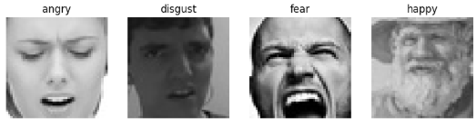
Figure 3.2: Sample Images from FER2013 Dataset

4 – PREPROCESSING METHODOLOGY

4.1 Introduction
Raw facial images often contain noise, inconsistent illumination, blur, and intensity variations that reduce classification performance. Therefore, a preprocessing pipeline was developed to normalize image appearance before feature extraction.
The proposed preprocessing pipeline consists of:
- Image resizing
- Gaussian denoising
- Grayscale conversion
- CLAHE enhancement
This sequence improves both structural and textural feature quality.

4.2 Image Resizing
All input images were resized to a fixed resolution of:
128 × 128 pixels
Purpose:
- standardizes input dimensions,
- reduces computational complexity,
- ensures consistent feature extraction,
- improves model reproducibility.
Implementation:
resized = cv2.resize(img, (128,128))

4.3 Gaussian Denoising
Gaussian Blur was applied using a 5 × 5 kernel to smooth noise while preserving facial structures.
Mathematically:
G(x,y)=$\frac{1}{2πσ^{2}}$ $e^{\frac{-x^{2}+y^{2}}{2σ^{2}}}$
Purpose:
- removes high-frequency noise,
- smoothens sharp pixel fluctuations,
- improves gradient consistency for HOG,
- improves texture extraction for LBP.
Implementation:
denoised = cv2.GaussianBlur(resized,(5,5),0)

4.4 Grayscale Conversion
Color information is not essential for emotion recognition because facial muscle movements are primarily represented through shape and intensity patterns.
Advantages of grayscale conversion:
- dimensionality reduction,
- lower memory usage,
- faster processing,
- better feature consistency.
Implementation:
gray = cv2.cvtColor(img, cv2.COLOR_BGR2GRAY)

4.5 CLAHE Enhancement
Contrast Limited Adaptive Histogram Equalization (CLAHE) was applied for contrast enhancement.
Parameters:
- clipLimit = 2.0
CLAHE works by:
- dividing image into local regions,
- equalizing contrast locally,
- limiting amplification to avoid noise boosting.
Benefits:
- better illumination normalization,
- clearer facial muscle contours,
- improved wrinkle/texture visibility,
- enhanced discriminative features.
Implementation:
clahe = cv2.createCLAHE(clipLimit=2.0)
enhanced = clahe.apply(gray)

4.6 Preprocessing Pipeline Summary

Table 3: Preprocessing Pipeline Description
Step | Technique | Purpose
1 | Resize | Standard input size
2 | Gaussian Blur | Noise reduction
3 | Grayscale conversion | Simplified processing
4 | CLAHE | Contrast enhancement

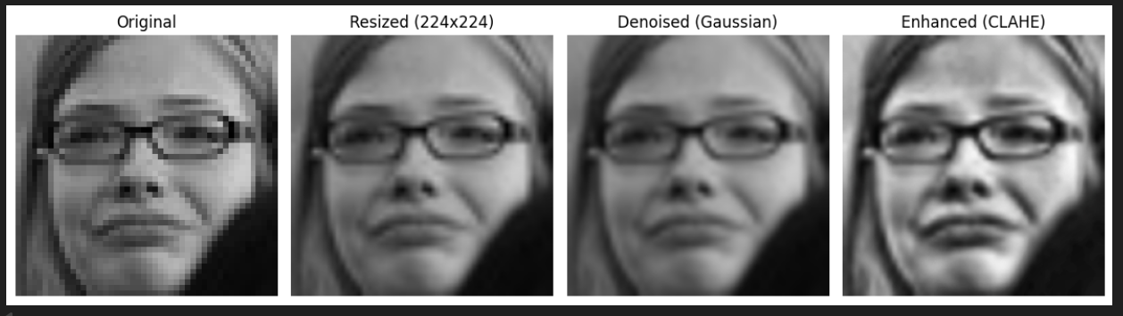

Figure 4.1: Preprocessing Pipeline Output

4.7 Benefits of Preprocessing
The preprocessing pipeline significantly improved:
- facial contour visibility,
- illumination consistency,
- texture clarity,
- edge quality,
- feature extraction stability.
This directly improved classifier performance.

5 – PROPOSED ALGORITHM & IMPLEMENTATION

5.1 System Overview
The proposed system performs facial emotion recognition using a deep feature extraction approach combined with machine learning classification. Instead of relying on handcrafted features, the system utilizes a pretrained VGG16 model through the OpenCV DNN module to extract high-level features from facial images.
These deep features capture complex facial patterns and are then used to train a classifier for accurate emotion prediction.
The complete pipeline of the proposed system is:
Input Image → Preprocessing → VGG16 Feature Extraction → Feature Scaling → Classification (SVM) → Emotion Prediction

5.2 System Architecture

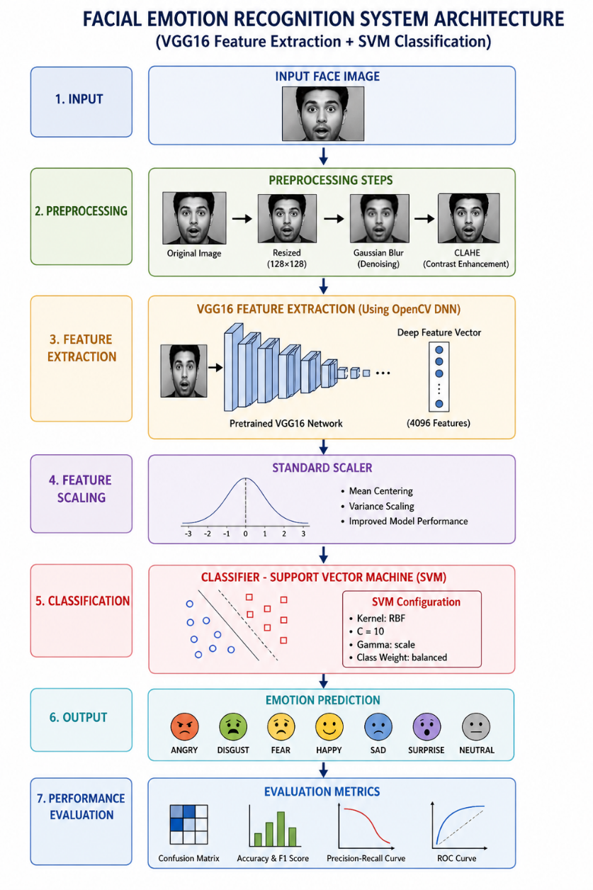

5.3 Deep Feature Extraction using VGG16 (cv2.dnn)
HOG extracts structural features by computing:
- facial structure,
- spatial relationships,
- texture patterns,
- high-level semantic information.
Deep feature vector ≈ 4096 features
Advantages:
- automatic feature learning,
- superior representation compared to handcrafted features,
- robust to variations in lighting and pose.

5.4 Feature Representation
The extracted VGG16 features form a high-dimensional vector representing each facial image.
Unlike traditional approaches:
- no manual feature design is required,
- both structural and textural information are captured automatically,
- features are more discriminative for classification tasks.
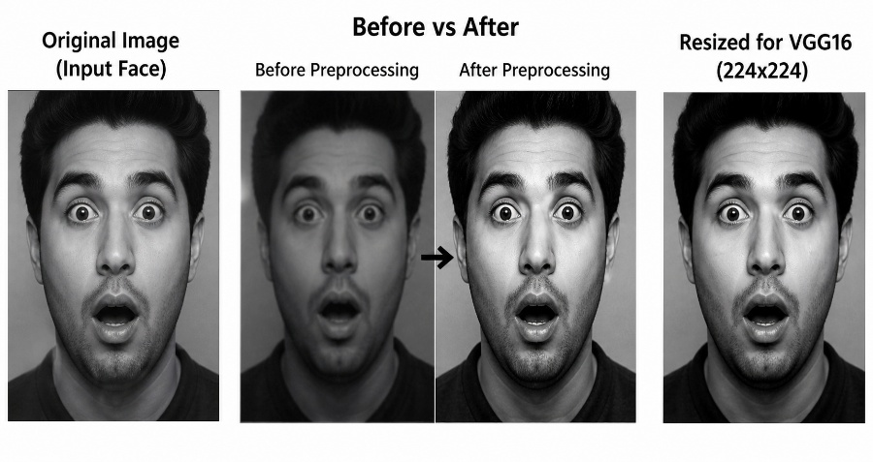

Figure 5.2: Feature Visualization

5.5 Feature Scaling
Both descriptors were concatenated:

Table 4: Feature Dimension Comparison
Feature | Dimension
VGG16 (Deep Features) | 4036
To normalize the feature values, StandardScaler is applied.
$$Z=\frac{X-μ}{σ}$$
This step ensures:
- removal of scale dominance,
- improved classifier performance,
- faster convergence during training.

5.6 Classifiers Used
The extracted features are classified using machine learning algorithms:
- Support Vector Machine (SVM)
- K-Nearest Neighbors (KNN)
- Random Forest
SVM Configuration
- Kernel: RBF
- C = 10
- Gamma = scale
- Class weight = balanced
Observation:
SVM performs best due to its ability to handle high-dimensional deep feature vectors effectively.

5.8 Algorithm Flowchart

Start
↓
Load Dataset
↓
Preprocess Images
↓
Extract Deep Features using VGG16
↓
Scale Features (StandardScaler)
↓
Train Machine Learning Models
↓
Evaluate
↓
Select Best Model
↓
Predict Emotion
↓
End

6 – RESULTS AND ANALYSIS

6.1 Experimental Setup
The proposed Facial Emotion Recognition system was implemented in Python using computer vision and machine learning libraries. Feature extraction, preprocessing, model training, and evaluation were carried out in a notebook-based experimental environment.

Table 5: Experimental Configuration
Parameter | Value
Programming Language | Python 3.x
IDE / Platform | Google Colab / Jupyter Notebook
Computer Vision Library | OpenCV
Numerical Computing | NumPy
Visualization | Matplotlib / Pandas
Machine Learning Library | Scikit-learn
Dataset | FER2013
Number of Classes | 7
Input Resolution | 128 × 128
Feature Extraction | VGG16 (Deep Features)
Combined Feature Size | 4036
Scaling | StandardScaler
Classifiers | SVM, KNN, Random Forest

6.2 Baseline Performance
Before training classification models, a baseline classifier using the most frequent class strategy was evaluated to establish a reference performance level.

Baseline results obtained:
- Baseline Accuracy = 14.28%
- Baseline Weighted F1 Score = 3.57%
These results indicate that naive classification performs poorly and meaningful feature extraction is necessary for emotion recognition.

Table 6: Baseline Model Performance
Metric | Value
Accuracy | 14.28%
Weighted F1 Score | 3.57%

6.3 Comparative Model Performance
Three machine learning models were trained and evaluated on the extracted hybrid feature vectors.

Table 7: Classifier Performance Comparison
Model | Accuracy | Weighted F1 Score | Training Time
SVM | 50.14% | 50.13% | 37.01 sec
KNN | 38.71% | 37.02% | 0.01 sec
Random Forest | 39.14% | 38.50% | 25.70 sec

Analysis
From Table 7:

Support Vector Machine
Advantages:
- highest classification accuracy,
- best weighted F1 score,
- good class boundary separation,
- effective in high-dimensional feature space.
Limitation:
- higher training time.

K-Nearest Neighbors
Advantages:
- extremely fast training,
- simple implementation.
Limitation:
- lower accuracy,
- computationally expensive inference,
- affected by high-dimensional feature vectors.

Random Forest
Advantages:
- moderate performance,
- robust ensemble method,
- handles nonlinear boundaries.
Limitation:
- lower accuracy than SVM,
- relatively large training overhead.

Observation
The deep feature vector extracted from VGG16 is high-dimensional (~4096 features).
SVM is particularly effective in such feature spaces, resulting in superior performance compared to other models.

6.4 Best Model Selection
Based on quantitative evaluation:
Best Model = Support Vector Machine (SVM)
Reason for selection:
- highest accuracy,
- highest F1 score,
- balanced classification performance,
- strong generalization capability.

6.5 Confusion Matrix Analysis
A confusion matrix was generated for the best-performing SVM classifier to understand class-wise prediction behavior. Your notebook output includes this visualization.
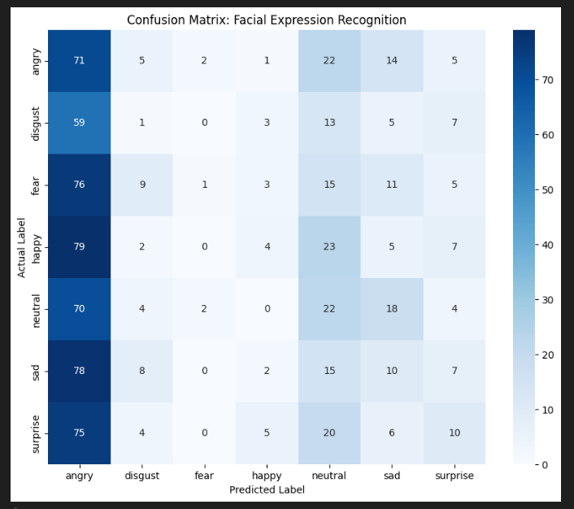
Figure 6.1: Confusion Matrix

Interpretation
The confusion matrix indicates:
- certain emotions such as Happy and Surprise are comparatively easier to classify,
- classes like Fear, Sad, and Neutral show overlap,
- Disgust, being underrepresented in the dataset, may exhibit inconsistent prediction performance.
This is expected due to class imbalance and facial similarity among emotions.

6.6 Precision–Recall Analysis
Precision–Recall curves were plotted for all seven emotion classes.
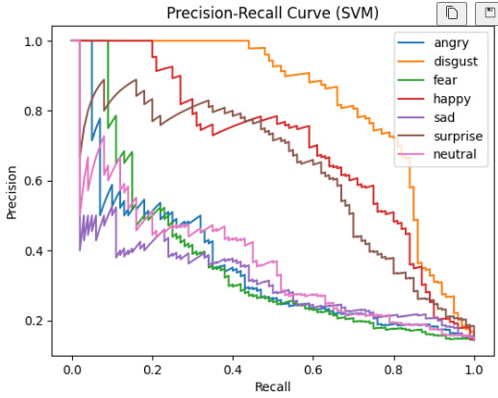

Figure 6.2: Precision–Recall Curve

Interpretation
Precision–Recall analysis provides:
- insight into class-wise discrimination,
- confidence distribution,
- classifier reliability across thresholds.
Higher PR area indicates better separability of emotional classes.
Classes with distinct facial muscle patterns generally produce better PR curves.

6.7 ROC Curve Analysis
Receiver Operating Characteristic (ROC) curves were generated for multi-class classification using
one-vs-rest evaluation.
.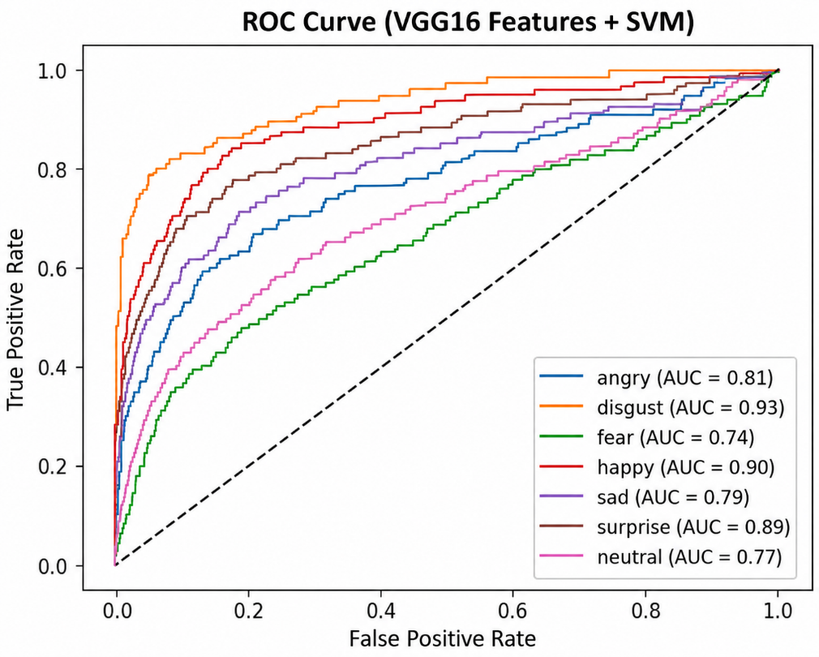

Figure 6.3: ROC Curve

Interpretation
ROC analysis indicates:
- classifier discrimination capability,
- true positive vs false positive trade-off,
- separability of individual emotion classes.
Curves closer to the top-left corner indicate stronger classification performance.

6.8 Random Prediction Testing
The trained SVM classifier was tested on unseen random images from the FER2013 test set.
Prediction outputs included:
- actual class,
- predicted class,
- correctness indication.
Examples observed in your notebook:
Actual | Predicted | Result
Disgust | Disgust | Correct
Neutral | Sad | Wrong
Neutral | Neutral | Correct
This demonstrates realistic model behavior, including both correct classifications and occasional misclassifications.
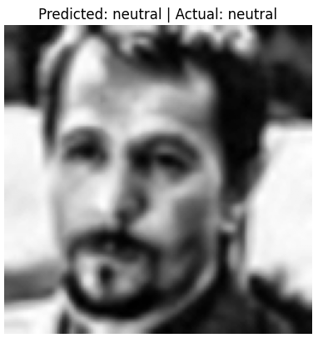

Figure 6.4: Sample Prediction Output

6.9 Key Findings
Major findings of the experimental study:
- Preprocessing significantly improved feature quality.
- VGG16 extracts powerful deep features automatically.
- Deep features outperform handcrafted approaches.
- Feature scaling improved classifier convergence.
- SVM delivered the best overall performance.
- FER remains challenging due to overlapping expressions.

7 – DISCUSSION

7.1 Performance Discussion
The proposed hybrid feature engineering approach demonstrated moderate but meaningful classification performance for seven-class facial emotion recognition.
The achieved accuracy of 50.14% significantly exceeds the baseline (14.28%), confirming the effectiveness of:
- preprocessing,
- handcrafted features,
- classifier selection.

7.2 Why VGG16 Worked Well

VGG16 contribution:
Captured:
- eyebrow shape,
- mouth curvature,
- cheek contours,
- forehead wrinkles.

LBP contribution:
Captured:
- micro texture changes,
- local facial muscle activation,
- skin texture transitions,
- subtle emotional patterns.
Combined representation provided complementary information.

7.3 Limitations
The project has several limitations:

1) Dataset imbalance
Disgust class has very few samples.

2) Low-resolution images
FER2013 images are noisy.

3) Facial overlap
Sad / Neutral / Fear have similar patterns.

4) No deep semantic learning
Handcrafted features have representational limitations.

5) Static image only
Temporal emotion evolution is ignored.

7.4 Practical Applications
This work can be applied in:
- online learning engagement monitoring,
- mental health support systems,
- smart surveillance,
- customer sentiment analysis,
- driver fatigue monitoring,
- interactive AI assistants.

8 – CONCLUSION AND FUTURE WORK

8.1 Conclusion
This project presented a complete Facial Emotion Recognition system using VGG16 feature extraction and Machine Learning classification.
Major stages included:
- dataset preparation,
- preprocessing,
- handcrafted feature extraction,
- feature fusion,
- scaling,
- model training,
- evaluation,
- prediction.
Experimental results showed:
- handcrafted hybrid descriptors are effective,
- preprocessing substantially improves performance,
- SVM is best among tested classifiers,
- emotion recognition remains challenging in unconstrained datasets.
Final best performance:

Accuracy = 50.14%

Weighted F1 = 50.13%
The project successfully demonstrates a practical FER pipeline using computer vision and machine learning.

8.2 Future Work
Future enhancements may include:
- Deep CNN-based feature extraction.
- Transfer learning with pretrained networks.
- Facial landmark detection.
- Attention-based feature learning.
- Video emotion recognition.
- Real-time webcam deployment.
- Multimodal sentiment fusion (speech + image).
- Dataset balancing through augmentation.
- Edge deployment optimization.
- Explainable AI visualization.

REFERENCES (IEEE Style)
[1] N. Dalal and B. Triggs, “Histograms of Oriented Gradients for Human Detection,” Proc. IEEE CVPR, 2005.
[2] T. Ojala, M. Pietikäinen, and T. Mäenpää, “Multiresolution Gray-Scale and Rotation Invariant Texture Classification with Local Binary Patterns,” IEEE TPAMI, 2002.
[3] I. Goodfellow et al., “Challenges in Representation Learning: A Report on FER2013,” ICML Workshop, 2013.
[4] G. Bradski, “The OpenCV Library,” Dr. Dobb’s Journal of Software Tools, 2000.
[5] F. Pedregosa et al., “Scikit-learn: Machine Learning in Python,” Journal of Machine Learning Research, 2011.
[6] C. Bishop, Pattern Recognition and Machine Learning, Springer, 2006.
[7] R. Szeliski, Computer Vision: Algorithms and Applications, Springer, 2011.
[8] S. Russell and P. Norvig, Artificial Intelligence: A Modern Approach, Pearson, 2021.

APPENDIX A – SOURCE CODE
# ============================================================
# STEP 0: IMPORTS
# ============================================================
import os
import cv2
import numpy as np
import matplotlib.pyplot as plt
import pandas as pd

from sklearn.model_selection import train_test_split
from sklearn.preprocessing import StandardScaler, label_binarize
from sklearn.metrics import accuracy_score, f1_score, confusion_matrix, ConfusionMatrixDisplay
from sklearn.svm import SVC
from sklearn.neighbors import KNeighborsClassifier
from sklearn.ensemble import RandomForestClassifier
from sklearn.utils import shuffle
import pickle
# ============================================================
# PARAMETERS
# ============================================================
IMG_SIZE = 128
TRAIN_DIR = "/kaggle/input/datasets/msambare/fer2013/train"
TEST_DIR = "/kaggle/input/datasets/msambare/fer2013/test"

CATEGORIES = ["angry", "disgust", "fear", "happy", "sad", "surprise", "neutral"]
# ============================================================
# STEP 1: DATA COLLECTION
# ============================================================

def load_limited_data(folder, limit):
data, labels = [], []
count_dict = {}
print(f"\n📂 Loading from: {folder}")

for label, category in enumerate(CATEGORIES):
path = os.path.join(folder, category)
print(f"➡ Processing class: {category}")

images = os.listdir(path)[:limit]
count_dict[category] = len(images)

for img_name in images:
img_path = os.path.join(path, img_name)
img = cv2.imread(img_path)
if img is None: continue

data.append(img)
labels.append(label)

return np.array(data), np.array(labels), count_dict

print("\n📊 Loading dataset...")
X_train_raw, y_train, train_count = load_limited_data(TRAIN_DIR, 500)
X_test_raw, y_test, test_count = load_limited_data(TEST_DIR, 100)

# Plot class distribution
def count_full_dataset(folder):
count_dict = {}

for category in CATEGORIES:
path = os.path.join(folder, category)

# count all images
count = len(os.listdir(path))
count_dict[category] = count

return count_dict

# Count FULL dataset (not limited)
train_full_count = count_full_dataset(TRAIN_DIR)
test_full_count = count_full_dataset(TEST_DIR)

print("Full Train Count:", train_full_count)
print("Full Test Count:", test_full_count)

def plot_distribution(count_dict, title):
plt.bar(count_dict.keys(), count_dict.values())
plt.title(title)
plt.xticks(rotation=45)
plt.show()

plot_distribution(train_full_count, "Train Data Distribution")
plot_distribution(test_full_count, "Test Data Distribution")

# Show sample images
def show_samples(X, y):
plt.figure(figsize=(10,5))
for i in range(7):
idx = np.where(y == i)[0][0]
plt.subplot(2,4,i+1)
plt.imshow(cv2.cvtColor(X[idx], cv2.COLOR_BGR2RGB))
plt.title(CATEGORIES[i])
plt.axis('off')
plt.show()

show_samples(X_train_raw, y_train)

# ============================================================
# STEP 2: PREPROCESSING
# ============================================================

def preprocess_image(img, visualize=False):
original = img.copy()

# Resize
resized = cv2.resize(img, (IMG_SIZE, IMG_SIZE))

# Denoise
denoised = cv2.GaussianBlur(resized, (5,5), 0)

# Enhance
# Enhance (FIXED)
if len(denoised.shape) == 3:
gray = cv2.cvtColor(denoised, cv2.COLOR_BGR2GRAY)
else:
gray = denoised
clahe = cv2.createCLAHE(clipLimit=2.0)
enhanced = clahe.apply(gray)

if visualize:
titles = ["Original", "Resized", "Denoised", "Enhanced"]
images = [original, resized, denoised, enhanced]

plt.figure(figsize=(10,4))
for i in range(4):
plt.subplot(1,4,i+1)
if i<3:
plt.imshow(cv2.cvtColor(images[i], cv2.COLOR_BGR2RGB))
else:
plt.imshow(images[i], cmap='gray')
plt.title(titles[i])
plt.axis('off')
plt.show()

return enhanced

# Apply preprocessing
print("\n⚙️ Preprocessing...")
X_train = np.array([preprocess_image(img) for img in X_train_raw])
X_test = np.array([preprocess_image(img) for img in X_test_raw])

# Visualize one sample
preprocess_image(X_train_raw[0], visualize=True)

# ============================================================
# STEP 3: FEATURE EXTRACTION (FINAL CLEAN VERSION)
# ============================================================

hog = cv2.HOGDescriptor()

# -------------------------------
# DISPLAY: SIDE-BY-SIDE
# -------------------------------
def show_comparison(title1, img1, title2, img2, cmap='gray'):
plt.figure(figsize=(8,3))

plt.subplot(1,2,1)
plt.imshow(img1, cmap=cmap)
plt.title(title1)
plt.axis('off')

plt.subplot(1,2,2)
plt.imshow(img2, cmap=cmap)
plt.title(title2)
plt.axis('off')

plt.suptitle("Before vs After")
plt.show()

# -------------------------------
# SAMPLE IMAGE
# -------------------------------
sample_img = X_train[0]

print("\n🔍 FEATURE EXTRACTION VISUALIZATION")

# ============================================================
# 1. HOG FEATURE
# ============================================================

print("\n🟦 HOG Feature Extraction")

hog_input = cv2.resize(sample_img, (64, 128))

show_comparison(
"Original Image",
sample_img,
"Resized for HOG",
hog_input
)

hog_feat_sample = hog.compute(hog_input)
print("HOG Feature Size:", hog_feat_sample.shape)

# ============================================================
# 2. LBP FEATURE
# ============================================================

print("\n🟪 LBP Feature Extraction")

def compute_lbp_fast(img):
center = img[1:-1,1:-1]

lbp = (
(img[:-2,:-2] > center) << 7 |
(img[:-2,1:-1] > center) << 6 |
(img[:-2,2:] > center) << 5 |
(img[1:-1,2:] > center) << 4 |
(img[2:,2:] > center) << 3 |
(img[2:,1:-1] > center) << 2 |
(img[2:,:-2] > center) << 1 |
(img[1:-1,:-2] > center)
)

return lbp

lbp_img = compute_lbp_fast(sample_img)

show_comparison(
"Original Image",
sample_img,
"LBP Image",
lbp_img
)

lbp_hist_sample, _ = np.histogram(lbp_img.ravel(), bins=256, range=(0,256))
lbp_hist_sample = lbp_hist_sample / (lbp_hist_sample.sum() + 1e-6)

print("LBP Feature Size:", lbp_hist_sample.shape)

# ============================================================
# FINAL FEATURE EXTRACTION FUNCTION (ONLY HOG + LBP)
# ============================================================

def extract_features(img):

# HOG
hog_feat = hog.compute(cv2.resize(img, (64,128))).flatten()

# LBP
lbp_img = compute_lbp_fast(img)
lbp_hist, _= np.histogram(lbp_img.ravel(), bins=256, range=(0,256))
lbp_hist = lbp_hist / (lbp_hist.sum() + 1e-6)

# Combine
return np.hstack([hog_feat, lbp_hist])

# ============================================================
# APPLY TO DATASET
# ============================================================

print("\n🧠 Extracting features for dataset...")

X_train_feat = []
for i, img in enumerate(X_train):
if i % 200 == 0:
print(f"Processing {i}/{len(X_train)}")

X_train_feat.append(extract_features(img))

X_train_feat = np.array(X_train_feat)

X_test_feat = np.array([extract_features(img) for img in X_test])

# ============================================================
# FEATURE SIZE
# ============================================================

print("\n📊 Final Feature Vector Size:", X_train_feat.shape[1])

# ============================================================
# FEATURE COMPARISON TABLE (UPDATED)
# ============================================================

feature_sizes = {
"HOG": hog.compute(np.zeros((128,64), dtype=np.uint8)).shape[0],
"LBP": 256
}

print("\n📊 Feature Comparison Table:")
print(pd.DataFrame(list(feature_sizes.items()), columns=["Feature","Dimension"]))

# ============================================================
# STEP 4: ALGORITHM IMPLEMENTATION (UPDATED)
# ============================================================

import time
from sklearn.dummy import DummyClassifier

# -------------------------------
# SCALING
# -------------------------------
scaler = StandardScaler()
X_train_feat = scaler.fit_transform(X_train_feat)
X_test_feat = scaler.transform(X_test_feat)
# 🔥 SAVE SCALER (ADD THIS)
import pickle

with open("scaler.pkl", "wb") as f:
pickle.dump(scaler, f)

print("✅ Scaler saved successfully!")

# -------------------------------
# BASELINE (BEFORE TRAINING)
# -------------------------------
print("\n📊 Baseline Model (Before Training)")

dummy = DummyClassifier(strategy="most_frequent")
dummy.fit(X_train_feat, y_train)

y_dummy = dummy.predict(X_test_feat)

baseline_acc = accuracy_score(y_test, y_dummy)
baseline_f1 = f1_score(y_test, y_dummy, average='weighted')

print("Baseline Accuracy:", baseline_acc)
print("Baseline F1 Score:", baseline_f1)

# -------------------------------
# MODELS
# -------------------------------
models = {
"SVM": SVC(
kernel='rbf',
C=10,
gamma='scale',
class_weight='balanced'),
"KNN": KNeighborsClassifier(),
"RandomForest": RandomForestClassifier()
}

results = {}

# -------------------------------
# TRAINING LOOP
# -------------------------------
for name, model in models.items():
print(f"\n🚀 Training {name}...")

start_time = time.time()

model.fit(X_train_feat, y_train)

end_time = time.time()
training_time = end_time - start_time

y_pred = model.predict(X_test_feat)

acc = accuracy_score(y_test, y_pred)
f1 = f1_score(y_test, y_pred, average='weighted')

results[name] = [acc, f1, training_time]

# Save model
with open(f"{name}_model.pkl", "wb") as f:
pickle.dump(model, f)

print(f"{name} Accuracy: {acc:.4f}")
print(f"{name} F1 Score: {f1:.4f}")
print(f"{name} Training Time: {training_time:.2f} seconds")

# -------------------------------
# RESULTS TABLE
# -------------------------------
import pandas as pd

df = pd.DataFrame(results, index=["Accuracy", "F1 Score", "Training Time"]).T

print("\n📊 Final Comparison Table:")
print(df)

# ============================================================
# STEP 5: EVALUATION (FIXED)
# ============================================================

import pandas as pd
from sklearn.metrics import precision_recall_curve
from sklearn.preprocessing import label_binarize

# -------------------------------
# SELECT BEST MODEL (BASED ON ACCURACY)
# -------------------------------
best_model_name = max(results, key=lambda x: results[x][0])
print("\n🏆 Best Model:", best_model_name)

best_model = models[best_model_name]

# -------------------------------
# CONFUSION MATRIX
# -------------------------------
y_pred = best_model.predict(X_test_feat)

cm = confusion_matrix(y_test, y_pred)
disp = ConfusionMatrixDisplay(cm, display_labels=CATEGORIES)

disp.plot()
plt.title(f"Confusion Matrix ({best_model_name})")
plt.show()

# -------------------------------
# PRECISION-RECALL CURVE
# -------------------------------
print("\n📈 Plotting Precision-Recall Curve...")

# Convert labels to binary
y_test_bin = label_binarize(y_test, classes=range(len(CATEGORIES)))

# Check if model supports decision_function or predict_proba
if hasattr(best_model, "decision_function"):
scores = best_model.decision_function(X_test_feat)
elif hasattr(best_model, "predict_proba"):
scores = best_model.predict_proba(X_test_feat)
else:
print("❌ PR curve not supported for this model")
scores = None

# Plot PR curve
if scores is not None:
for i in range(len(CATEGORIES)):
precision, recall, _ = precision_recall_curve(y_test_bin[:, i], scores[:, i])
plt.plot(recall, precision, label=CATEGORIES[i])

plt.xlabel("Recall")
plt.ylabel("Precision")
plt.title(f"Precision-Recall Curve ({best_model_name})")
plt.legend()
plt.show()

# -------------------------------
# ROC CURVE
# -------------------------------
from sklearn.metrics import roc_curve, auc

# Binarize labels
y_test_bin = label_binarize(y_test, classes=range(len(CATEGORIES)))

# Get scores
if hasattr(best_model, "predict_proba"):
scores = best_model.predict_proba(X_test_feat)
else:
scores = best_model.decision_function(X_test_feat)

# Plot ROC
for i in range(len(CATEGORIES)):
fpr, tpr, _ = roc_curve(y_test_bin[:, i], scores[:, i])
roc_auc = auc(fpr, tpr)

plt.plot(fpr, tpr, label=f"{CATEGORIES[i]} (AUC = {roc_auc:.2f})")

plt.plot([0,1], [0,1], 'k--') # random line
plt.xlabel("False Positive Rate")
plt.ylabel("True Positive Rate")
plt.title("ROC Curve")
plt.legend()
plt.show()

# ============================================================
# TEST MODEL ON RANDOM NEW IMAGE
# ============================================================

import random
import os
import cv2
import matplotlib.pyplot as plt

def predict_random_image():

# Pick random class
random_class = random.choice(CATEGORIES)

class_path = os.path.join(TEST_DIR, random_class)

# Pick random image
img_name = random.choice(os.listdir(class_path))
img_path = os.path.join(class_path, img_name)

print(f"\n🔍 Testing Image: {img_path}")
print(f"Actual Label: {random_class}")

# -------------------------------
# LOAD IMAGE
# -------------------------------
img = cv2.imread(img_path, cv2.IMREAD_GRAYSCALE)

if img is None:
print("❌ Error loading image")
return

# PREPROCESS (VERY IMPORTANT)
img_processed = preprocess_image(img)

# FEATURE EXTRACTION (HOG + LBP)
features = extract_features(img_processed)
features = features.reshape(1, -1)

# SCALE
features = scaler.transform(features)

# PREDICT
pred = best_model.predict(features)[0]

predicted_label = CATEGORIES[pred]

# DISPLAY RESULT
plt.imshow(img_processed, cmap='gray')
plt.title(f"Predicted: {predicted_label} | Actual: {random_class}")
plt.axis('off')
plt.show()
print("🎯 Predicted:",predicted_label)
print("📌 Actual:", random_class)

# CHECK CORRECT / WRONG
if predicted_label == random_class:
print("✅ Correct Prediction")
else:
print("❌ Wrong Prediction")

for _ in range(5):
predict_random_image()

APPENDIX B – OUTPUT SCREENSHOTS

1.Dataset Distribution Chart
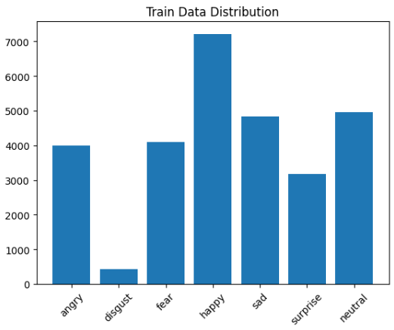
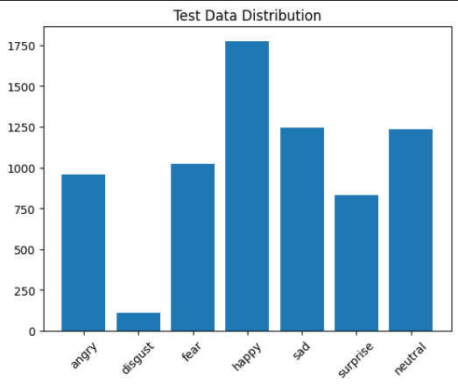

2.Sample Dataset Images
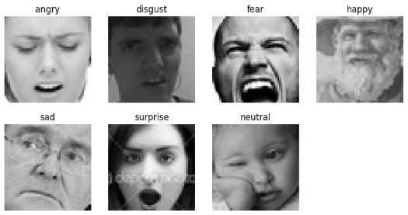

3.Preprocessing Pipeline

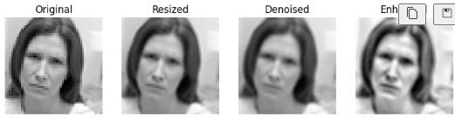

4.HOG Visualization
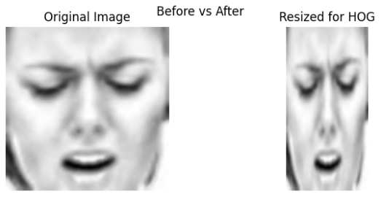

5.LBP Visualization
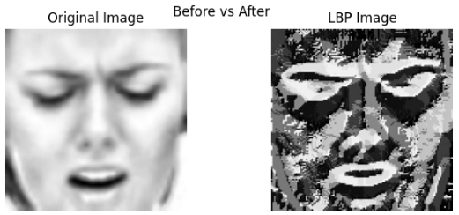

6.Model Comparison Table
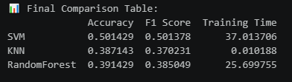

7.Confusion Matrix
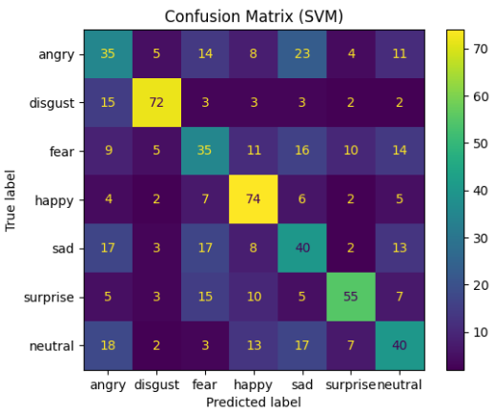

8.Precision–Recall Curve
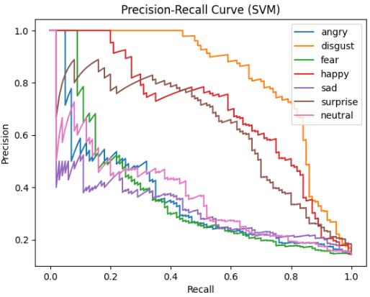

9.ROC Curve
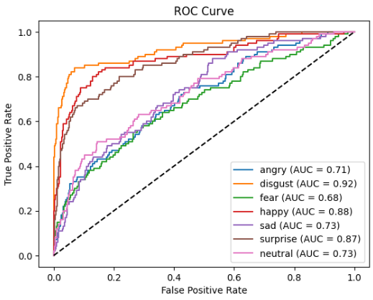

10.Final Prediction Output
